# **IgniteHR Project Document**

## 1. Project Overview

IgniteHR is an advanced HR dashboard designed to streamline employee management, payroll, leave requests, and performance analytics. Built with a focus on efficiency and automation, IgniteHR supports Role-Based Access Control (RBAC) to manage permissions effectively across different user roles. The platform offers automatic notifications for leave approvals, payroll updates, and policy changes, ensuring smooth communication between HR and employees. The leave management system is equipped to handle requests through automated email workflows and provides a comprehensive view of leave balances, approvals, and deductions.

IgniteHR is designed to scale seamlessly with microservices architecture, providing flexibility to integrate with third-party payroll systems and AI-driven analytics in future versions.

2. Key Features

* **Automated Email Summaries**
  + Send weekly or monthly summary emails to employees, covering payroll, leave balances, and upcoming deadlines.
* **Employee Management (CRUD operations)**
  + Manage employee profiles, track employment status, and update personal information.
* **Payroll Management with Custom Salary Settings**
  + Configure salary settings, deductions, and generate payroll reports automatically every 30 days.
* **Leave Management with Automated Email Notifications**
  + Process leave requests via email and notify employees about approvals or rejections.
* **Real-time Analytics and Reports**
  + Provide visual reports on attendance, payroll distribution, and leave usage.
* **Role-based Access Control (RBAC)**
  + Define access levels for Admin, HR Manager, and Employees to protect sensitive information.
* **Performance Monitoring**
  + Monitor API performance and system health using k6 and Grafana dashboards.

## 3. Technology Stack

* **Backend:** Golang (Gin Framework), MongoDB, Redis
* **Frontend:** ReactJS, TailwindCSS
* **APIs:** RESTful, Swagger for API Documentation
* **CI/CD:** Jenkins, Docker, Kubernetes
* **Cloud:** GCP for cost efficiency

4. Architecture Overview

* Microservices architecture
* Caching with Redis
* Containerization using Docker

5. API Documentation

* Auth APIs
* Flow Diagrams
* Flow diagrams for Each Login
* Employee User Flow  
    
  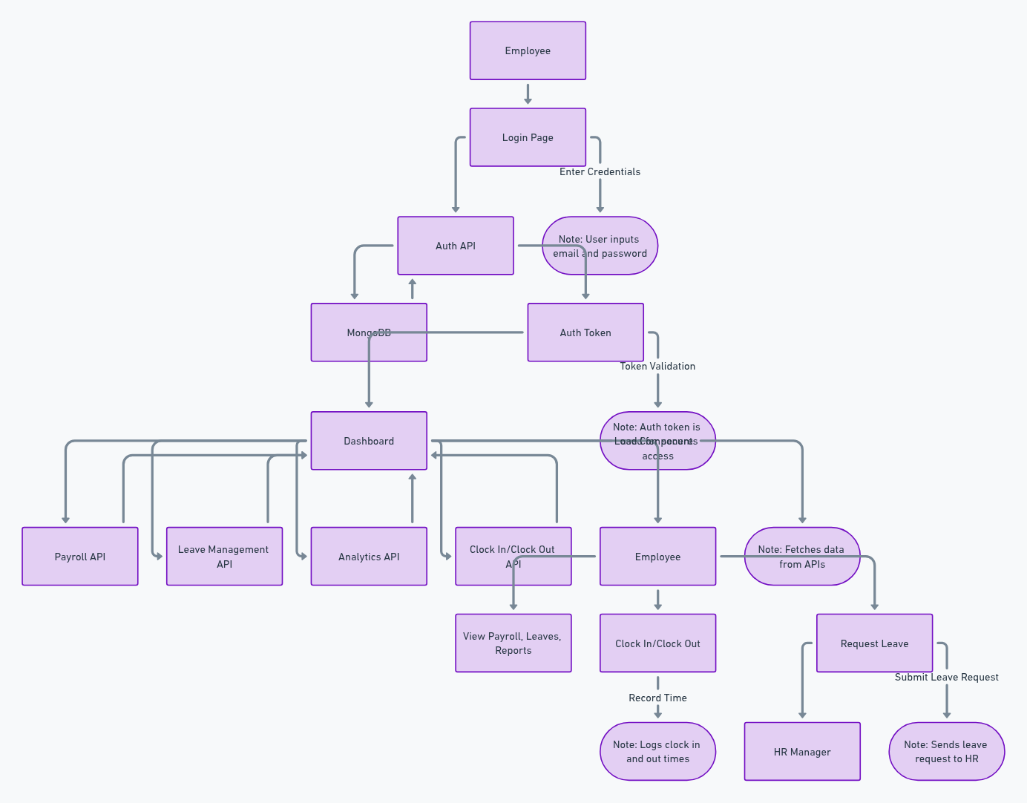
* HR User Flow  
    
  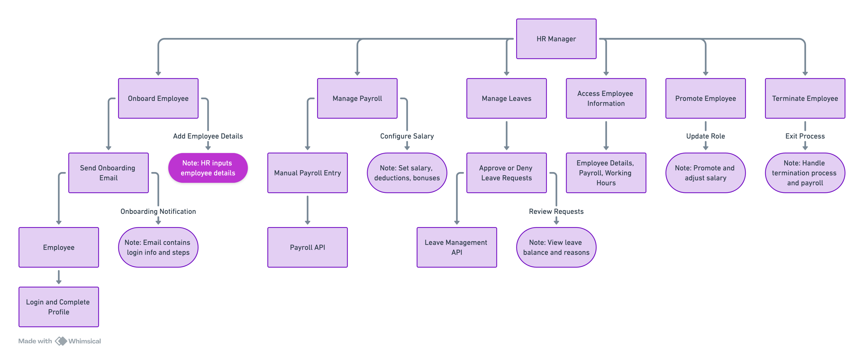
* Admin user flow

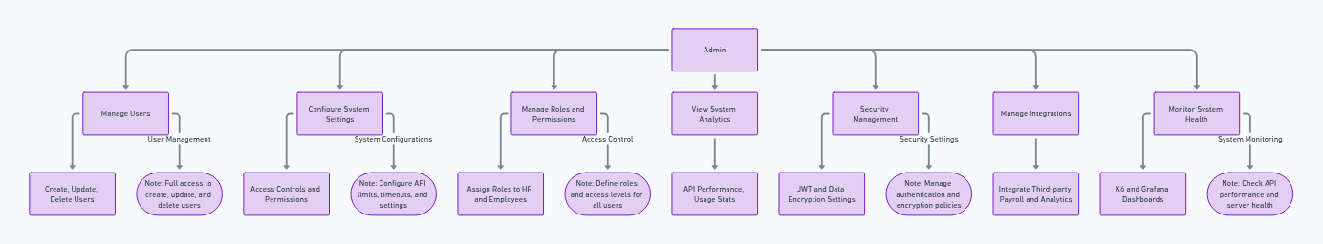

* Employee Management APIs
* Payroll APIs
* Leave Management APIs

## 6. Database Structure

* MongoDB collections for Employees, Payroll, Leaves

**Collections and Schema Design**

* **Employees Collection:** Stores employee details such as name, employee ID, role, contact information, salary, working hours, and leave balances.
* **Payroll Collection:** Manages salary details, deductions, bonuses, and payroll history for each employee.
* **Leaves Collection:** Tracks leave requests, status (pending, approved, rejected), leave type (paid, unpaid), and leave history.

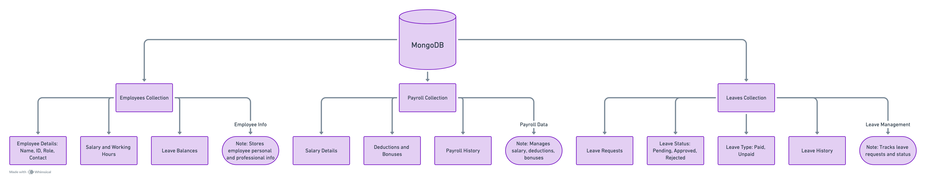

## 7. User Roles and Permissions

* Admin: Full Access
* HR Manager: Limited Access
* Employee: View Access

## 8. Performance and Security

* Load Testing: k6
* Security: JWT Authentication, Data Encryption

## 9. Future Enhancements

* AI-driven analytics
* Integration with third-party payroll systems

## 10. Conclusion

IgniteHR is an advanced HR management system designed to streamline employee management, payroll processing, and leave requests through automation and real-time analytics. Built on a microservices architecture using Golang, MongoDB, and Redis, it ensures high performance, security, and seamless scalability. The platform's role-based access control (RBAC) and automated email notifications simplify HR operations and enhance communication. Future enhancements include AI-driven analytics and integration with third-party payroll systems, positioning IgniteHR as a comprehensive solution for modern HR needs.